CREATING DATABASE IN CLOUDANT DB

|  |  |
| --- | --- |
| **Team ID** | **PNT2022TMID40963** |
| **Project Name** | **IoT Based Smart Crop Protection System For Agriculture** |

**Cloudant DB:**

Cloudant is an IBM software product, which is primarily delivered as a cloud- based service. Cloudant is a non-relational, distributed database service of the same name. Cloudant is based on the Apache-backed CouchDB project and the open source BigCouch project.Cloudant's service provides integrated data management, search, and analytics engine designed for web applications.Apache CouchDB is an open-source document-oriented NoSQL database.

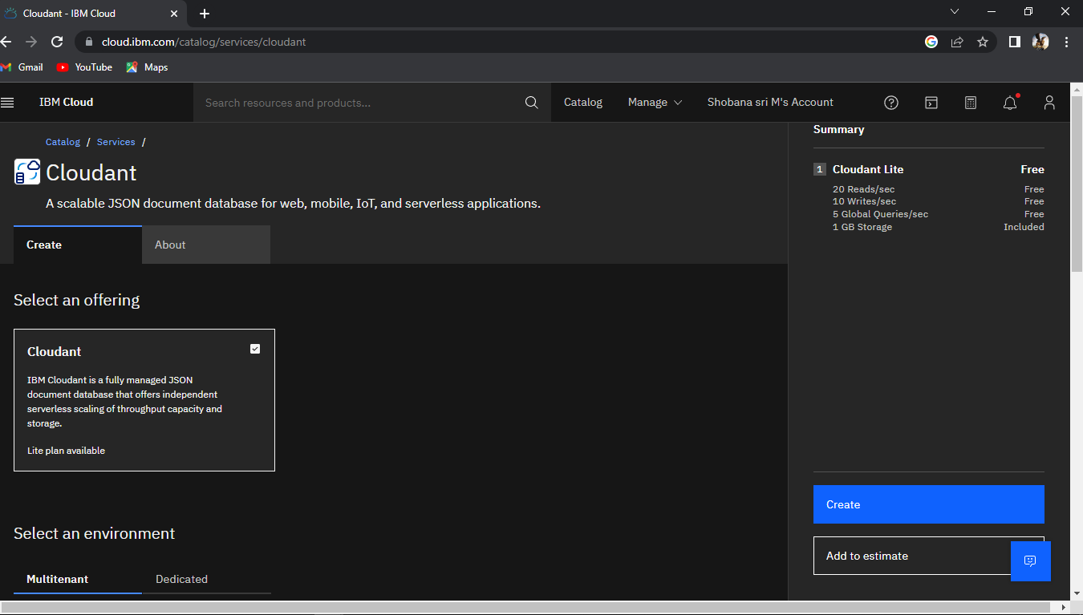

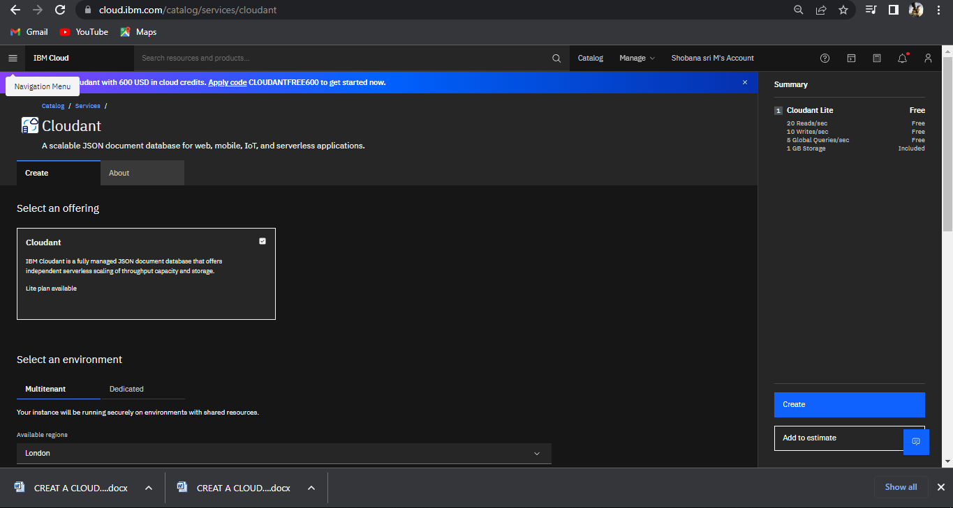

SUBMITTED BY

SHOBANA SRI.M

VEDHAPRIYA.K.M

JAYASRI.G